VICTORIAN CIVIL AND ADMINISTRATIVE TRIBUNAL
planning and environment LIST | vcat reference No. P990/2020  Permit Application no. MPS/2019/753

APPLICANT | Clinton Swanson-Hill
responsible authority | Moreland City Council
SUBJECT LAND | 110 Wilson Street, Brunswick
HEARING TYPE | Hearing
DATE OF HEARING | 30 September 2020
DATE OF ORDER | 18 January 2021
citation | Swanson-Hill v Moreland CC [2021] VCAT 39

Order
- In application P990/2020 the decision of the responsible authority is set aside.
- In planning permit application MPS/2019/753 a permit is granted and directed to be issued for the land at 110 Wilson Street, Brunswick in accordance with the endorsed plans and the conditions set out in Appendix A. The permit allows:
- Partial demolition;
- Alteration; and
- Double storey extension to the rear of an existing dwelling

Michael Nelthorpe Member

Appearances
For applicant | Mr Mark Waldon, town planner of St Wise Pty Ltd.
For responsible authority | Ms Sunny Shan, urban planner.

Information
Description of proposal | Demolition of the rear rooms of a dwelling, alterations and a double-storey extension to the rear of the dwelling.
Nature of proceeding | Application under section 77 of the Planning and Environment Act 1987 – to review the refusal to grant a permit.
Planning scheme | Moreland Planning Scheme
Zone and overlays | Neighbourhood Residential Zone Schedule 1  Development Contributions Plan Overlay Schedule 1  Heritage Overlay Schedule 139.
Permit requirements | Clause 32.09-5: to construct or extend a dwelling on a lot of less than 300 square metres; and  Clause 43.01-1: to demolish a building and construct a building or construct or carry out works.
Relevant scheme policies and provisions | Clauses 11, 15, 16, 21.02, 21.03, 22.01, 22.06, 32.09, 43.01, 54, 65 & 71.02.
Land description | This rectangular site has 5.09 metre frontages to Wilson and Gold Streets, a 28.9 metre depth and an area of 147 square metres. A single-storey Victorian terrace house occupies the site and faces Wilson Street.  It is the second from the west of a row of 16 properties of a similar size. Each contains an original dwelling with or without ground and/or first floor extensions except for one or two dual occupancy developments where the second dwelling faces Gold Street.

Reasons

What is this proceeding about?
- Clinton Swanson-Hill (‘the applicant’) seeks a permit to extend the existing dwelling at 110 Wilson Street, Brunswick. Moreland City Council (‘the council’) refused to grant a permit, saying the size of the extension and its boundary-to-boundary construction caused unreasonable amenity impacts on its neighbour’s secluded private open space; and did not respect the neighbourhood’s character.
- These are the key issues in this proceeding.
- At the hearing, the applicant tendered ‘discussion plans’ that reduce the length of the first-floor extension by 2 metres, They also proposed to articulate the west facing wall by cladding it in brickwork at ground level and textured sheeting at the upper level. At a later date and on my request, the applicant submitted revised plans correcting the length of the dwelling at 112 Wilson Street.
- I gave the parties an opportunity to make further submissions on both sets of plans. The council maintains its grounds of refusal.

the site and its context
- This is shown in the aerial photograph below:
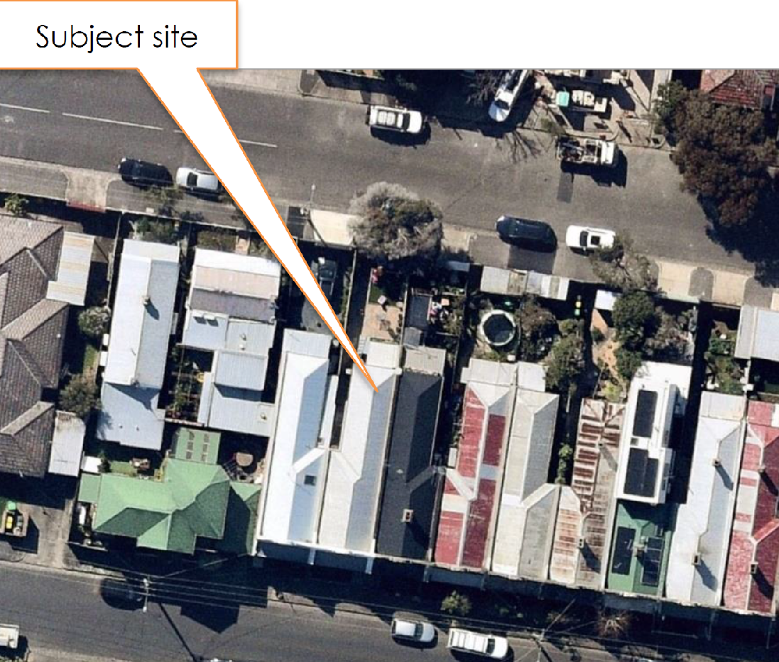

The proposal
- The ground and first floor layout are shown below:
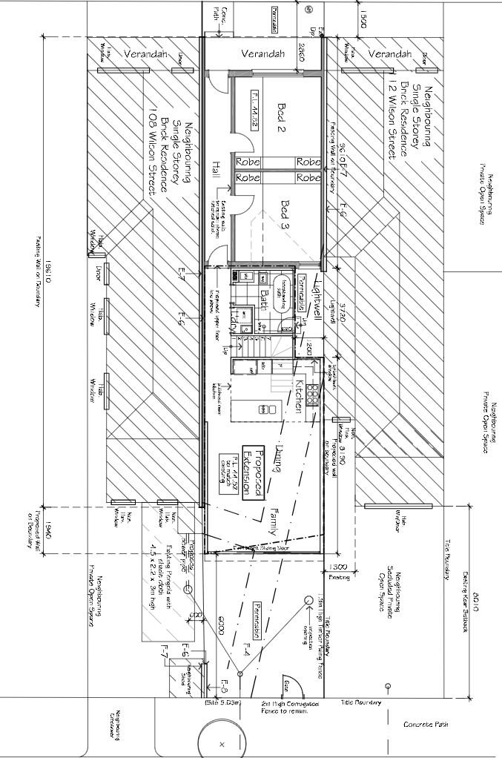

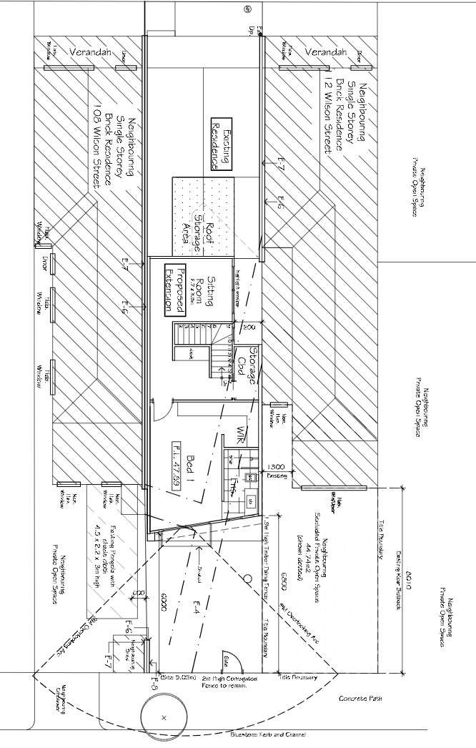
- The following aspects of the plans are relevant to my decision:
- The extension is built to both side boundaries and the light well is adjacent to the filled in section of its western neighbour;
- The wall on the eastern boundary extends 1.94 metres beyond the dwelling to the east;
- The wall on the western boundary extends 1.2 metres beyond the dwelling to the west (approximated from the plans); and
- The extension’s walls are 6.8 metres high and are recessed at the western side because of the angled first floor rear wall.

Are the impacts on the amenity of the neighbouring areas of secluded private open space acceptable?
- The extension’s visual impact when viewed from the neighbour’s rear courtyards, and the increased shadowing of these courtyards by the extension are the relevant amenity issues in this case.

The extension’s visual impact
- The Planning Scheme provides guidance on the length and height of walls on or near boundaries in order to limit the impact on the amenity of the existing dwellings. The amenity impacts of concern are loss of daylight to windows, overshadowing of open space areas and loss of amenity through a sense of enclosure.
- Based on the council’s calculations (which were not disputed), the guidance suggests that the walls on these boundaries should not exceed 14.7 metres, whereas the ground floor walls are 17.8 metres long – a difference of 3.1 metres. The standard also requires the height of walls on boundaries to average 3.2 metres with no part being higher than 3.6 metres whereas the proposed walls are 6.8 metres high – a difference of at least 3.2 metres.
- The Planning Scheme guidance on the setback of walls from boundaries is shown in the diagram below:
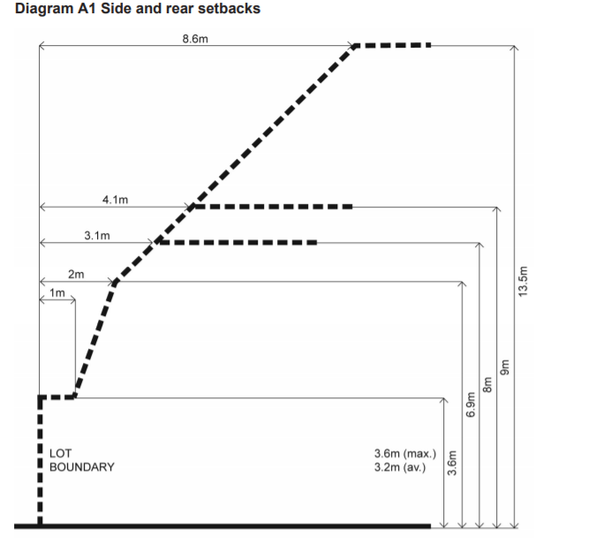
- Based on this diagram, the upper 3.2 metres of the walls of this extension should be set back one metre from the boundaries at the lowest point and almost two metres at the highest point.
- The recent case of Browne v Moreland involved 106 Wilson Street (two properties to the east). Another division of the Tribunal found that the walls of an extension comparable to what is before me, did not limit the amenity impact on the adjoining property’s rear courtyard to an acceptable degree. It supported conditions imposed by the council that required:
a) An increased setback of the first floor from the north boundary, so that the first floor (including any wing wall) does not project beyond the northern building line at 104 Wilson Street; and
b) That part of the ground floor east boundary wall that projects beyond the building line of the adjoining property at 104 Wilson Street modified to have an average height of 3.2 metres above natural ground level, to achieve compliance with Standard A11 from Clause 54.04-2 (walls on boundaries) of the Moreland Planning Scheme).
- The council says that I should follow this decision as it is the most recent guidance on this issue.
- The applicant disagrees. They envisage that this series of properties will continue to evolve, with double-storey extensions and small rear courtyards becoming the norm. They also say that 106 Wilson Street is in the middle of this series of terraces whereas 110 Wilson Street is the second last in the row. They also say that the neighbour to the east intends to extend their dwelling and supports the proposal as they intend to do something similar.
- My response to these submissions is that I am influenced by the decision in Browne v Moreland CC, yet I do not find it determinative. I am aware of the diversity of extensions nearby, including those with two storey walls at or near the rear boundaries. Thus, the range of possible outcomes is quite broad.
- I agree with the applicant’s submission that most of these small terrace houses will be extended in the coming decades. This trend has occurred across inner Melbourne and it is has occurred here.
- I disagree with their second submission, as I do not see a substantive difference between 106 and 110 Wilson Street regarding the impact on the amenity of the adjoining properties. The key difference is the neighbour to the east supports the proposal.
- In this context, I support the proposed length of ground and first floor walls. The critical impact is to 112 Wilson Street and I am satisfied that the combination of the modest length beyond that dwelling (2 metres at ground floor and 1.2 metres at first floor) is a reasonable incursion. It will have some impact but not enough to be considered unacceptable.
- However, I find that the height of this wall on the boundary is not acceptable. I consider that its 6.4 metre sheer height is problematic, particularly given that it sits opposite a light well that minimises the width of built form at the rear of 112 Wilson Street. I find that the visual benefit of this lightwell needs to be respected by setting the first-floor form 1300mm off the boundary for the length of that lightwell.
- This aspect of my decision is influenced by Browne. The plans before the Tribunal in that case are reproduced below and show the first floor is setback the width and length of the adjoining lightwell. I see merit in this for reasons of amenity and character. On amenity, it provides visual interest and relief while on character, it retains a semblance of the original form of these dwellings.
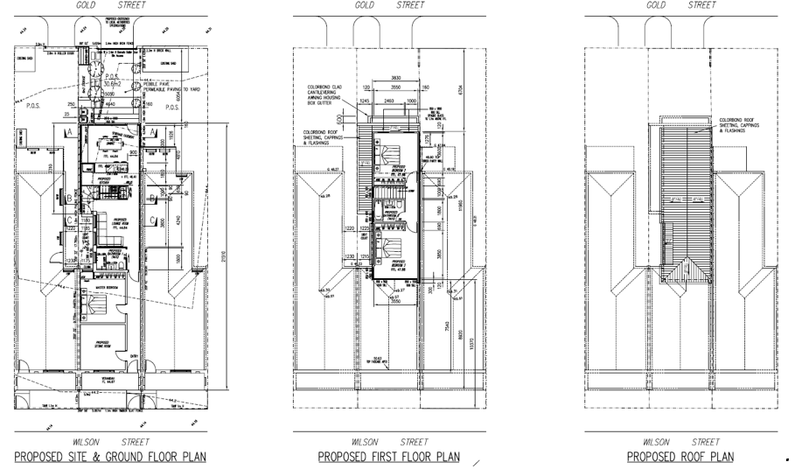
- The impact of this setback is not as great in the proposal before me because the owners of 112 Wilson Street have filled in most of the setback. I will only require the 1 metre setback for the length of the first-floor bedroom. I have considered the impact on the layout of the proposed first floor and recognise that it is significant. However, I find it is necessary to ensure a satisfactory amenity outcome for 112 Wilson Street.
- Separately, I consider this change can occur by a condition on the permit. Any consequent changes to the internal layout of the proposal are unlikely to have amenity impacts.

The extension’s overshadowing impact
- The shadow diagrams supplied with the ‘discussion’ plans show a marginal increase in shade falling on 112 Wilson Street’s courtyard between 9am and noon on the equinox. This shade is caused by the ground floor wall, not the first-floor wall. I find that this is an acceptable outcome in this inner urban setting.

The extension’s overlooking impact
- The proposal includes an extruding frame around the proposed first-floor bedroom window. This reduces the overlooking of most of the courtyards of 108 and 112 Wilson Street, leaving only small areas at the rear of these courtyards where views are available.
- This is acceptable given that these areas are the least sensitive parts of the adjoining courtyards.

Is the response to the neighbourhood’s character acceptable?
- I find that the proposal, as modified by the conditions I have imposed, has no adverse impacts on the neighbourhood’s character. Rather, it adds one example of a two-storey extension to those that already existing in the neighbourhood.
- I agree with the applicant that the siting of such extensions at the rear of these dwellings results from their heritage values. Accordingly, extensions to these dwellings are setback some distance from the dwellings’ façade. The proposal before me shares this characteristic thus I find that it is an acceptable response.

What conditions are appropriate?
- I have reviewed the draft conditions circulated by the council and have deleted the condition requiring underground telecommunication and power connections because other authorities determine these connections.

Conclusion
- For the reasons outlined above, the decision of the responsible authority is set aside. A permit will issue.

Michael Nelthorpe Member

Appendix A – Permit Conditions

Permit Application No | MPS/2019/753
Land | 110 Wilson Street, Brunswick

What the permit allowS
In accordance with the endorsed plans:
- Partial demolition;
- Alteration; and
- double storey extension to the rear of an existing dwelling.

Conditions
- Before the development commences, amended plans to the satisfaction of the Responsible Authority must be submitted to and approved by the Responsible Authority. When approved, the plans will be endorsed and will then form part of the permit. The plans must be drawn to scale with dimensions and must be generally in accordance with the plans dated 30 November 2020) but modified to show:
  - The western wall of the first-floor bedroom setback 1300mm from the shared boundary;
  - the western wall of the extension clad in brickwork at ground level and textured sheeting at the upper level.
- The development as shown on the endorsed plans must not be altered without the written consent of the Responsible Authority. This does not apply to any exemption specified in Clauses 62.02-1 and 62.02-2 of the Moreland Planning Scheme unless specifically noted as a permit condition.
- All stormwater from the land, where it is not collected in rainwater tanks for re-use, must be collected by an underground pipe drain approved by and to the satisfaction of the Responsible Authority (Note: Please contact Moreland City Council, City Infrastructure Department).
- Prior to the issue of an Occupancy Permit or issue of a Statement of Compliance, whichever comes first, all boundary walls must be constructed, cleaned and finished to the satisfaction of the Responsible Authority.
- This permit as it relates to development (buildings and works) will expire if one of the following circumstances applies:
  - The development is not started within two (2) years of the issue date of this permit.
  - The development is not completed within four (4) years of the issue date of this permit.
In accordance with section 69 of the Planning and Environment Act 1987, an application may be submitted to the responsible authority for an extension of the periods referred to in this condition.
– End of conditions –

The submissions of the parties and the statements of grounds filed have been considered in the determination of the proceeding. In accordance with the practice of the Tribunal, not all of this material will be cited or referred to in these reasons.
At clause 54.04-2.
At clause 54.04-1.
Browne v Moreland CC [2020] VCAT 858

